**Data**

Air travel has become an integral part of our lives. The air traffic growth is estimated to increase at an annual rate of 5.5%. With such a large system and the number of people opting for this faster mode of transportation, safety concerns become paramount. Most people think of only the aircraft when it comes to travel. But indeed it involves a synergistic and synchronized working of the air operations, air traffic control, crews, airports and weather and security services. To have a closer look at the tragic reality of airplane crashes, my project consists of various different statistics on airplane crashes between 1908 – 2009.

**Metadata:**

The metadata of the dataset is as per the picture here.

Crash calculations are made with respect to important attributes from this dataset.

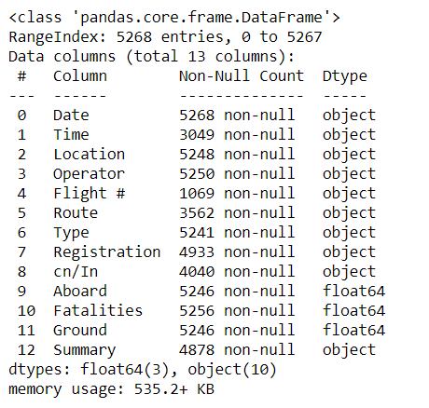

**Sample Data:**

The sample data looks like this

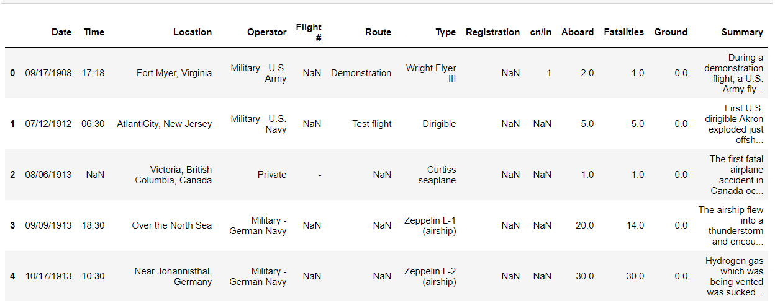

**Crash v Decade:**

The graph represents the number of crashes occured per decade from 1908-2009.

It is observed that crashes increased eventually from the 1910's to 1980’s and showed a drastic reduction in 2010’s. It is observed that most crashes have occurred during the 1980’s.

Significantly less number of crashes occured in the 2010’s. It could be due to the improvement of the technology.

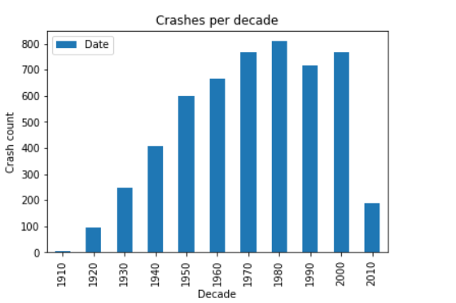

**Crashes v Time:**

It is observed that most of the crashes happened during the mid day in the sunlight. Around 12PM and 15PM. Such an irony.

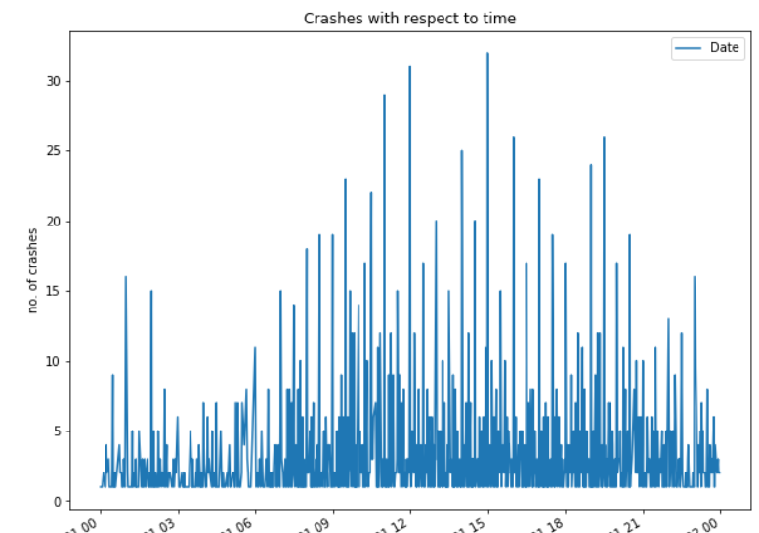

**Crashes v Operator:**

When a graph is plotted for Crash counts v Operator, it is observed that most of the crashes happened with the operator Aeroflot and Military - U.S Air Force as expected with around 175 crashes each. This could be due to the wars.

The graph here is displaying the top 10 Operators with the highest number of crashes. There are other private operators involved in the Crashes.

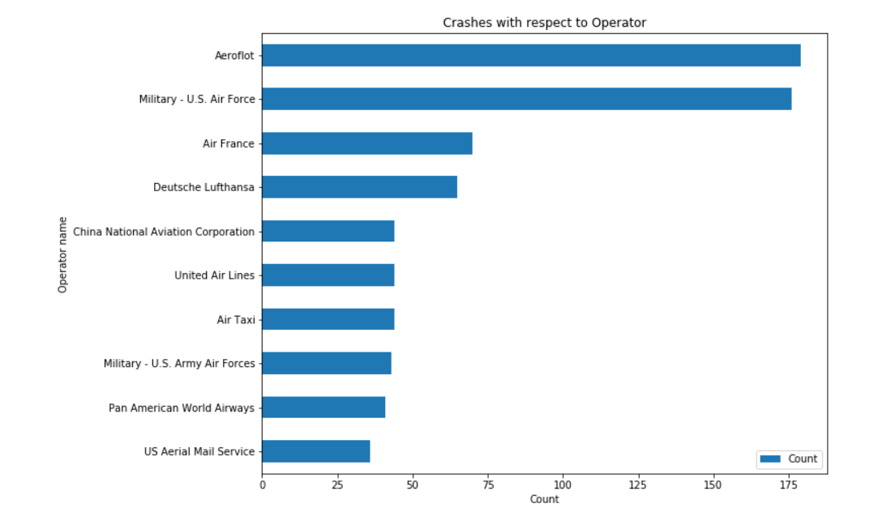

**Crashes v Location:**

From the graph plotted between the number of crashes and Location, it is observed that most of the Locations are unidentified. Next goes to Brazil and Russia. Again, this plot is just the top 10 Locations. The Dataset has many more locations.

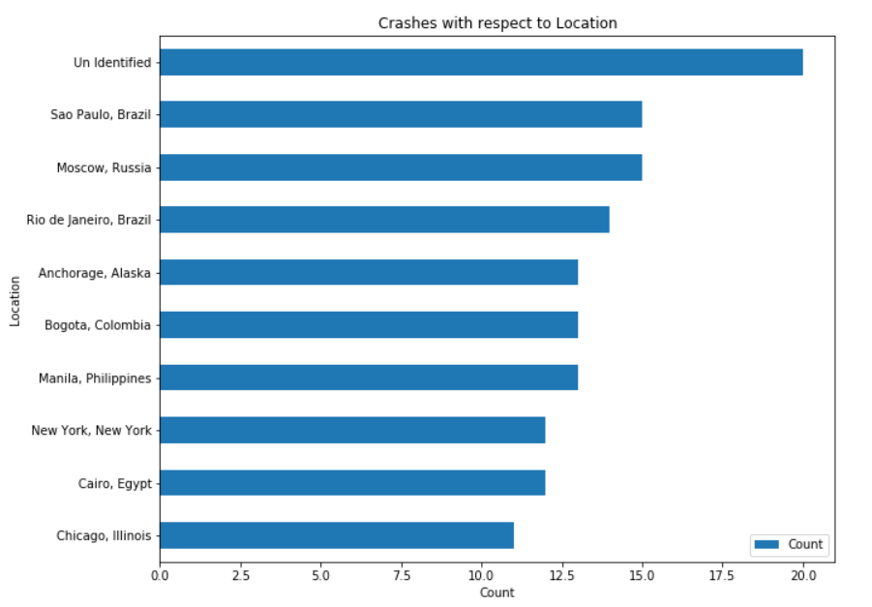

**Crash v Route:**

Again, it is observed from the graph plotted between the crash counts and route that the majority of the crashes occurred in an unidentified route. Second place goes to Training.

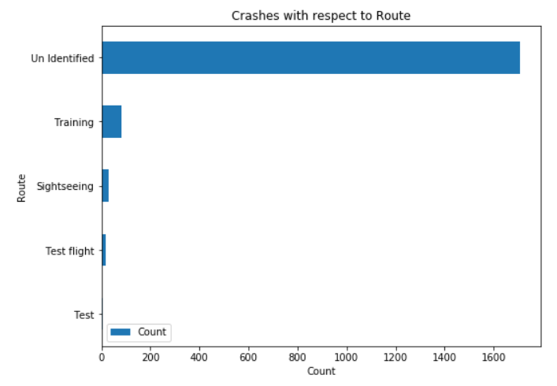

**Crash v Flight Type:**

From the plot generated between Crash count and Flight type, it is observed that most of the crashes occurred with the Flight type *Douglas DC - 3*. There is a possibility that mostly this flight is used in wars considering the previous graphs.

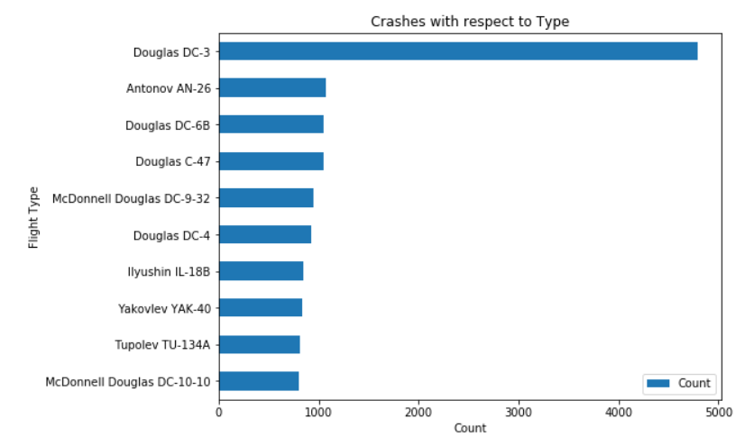

**Fatalties v Flight Type:**

The graph plotted between the number of fatalities occurred v Flight type is similar to the Crashes v Flight type. Most of the fatalities occurred during the *Douglas DC - 3* crash.

